FAP-tag ®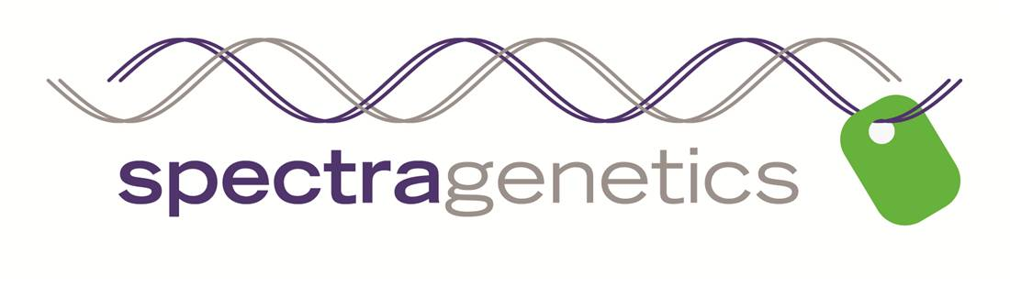

**LIMITED USE LICENSE AGREEMENT - READ CAREFULLY**

**BY OPENING PACKAGING ENCLOSING THE MATERIALS, RECIPIENT ACCEPTS THE TERMS AND CONDITIONS BELOW.**

**1. Legal Agreement.** This Limited Use License Agreement (the “Limited Use Agreement”) constitutes a legal agreement between the addressee and his or her organization (collectively, “Recipient”) and SpectraGenetics LLC (“Spectra”).

**2. Controlling Terms.** This Limited Use Agreement sets forth herein the only terms and conditions governing the use of the enclosed product.

**3a. License Grant.** Subject to the terms and conditions of this Limited Use Agreement, Spectra hereby grants to Recipient a non-transferable, non-exclusive license to use the enclosed DNA and fluorogenic dye (the “Materials”) for research purposes only.

**3b. Sublicense Grant.** Spectra hereby grants a nonexclusive non-transferable sublicense, under rights licensed by Spectra from Sharp Edge Labs, Inc. to use said Materials under the terms and conditions specified in sections 1-11 of this Limited Use Agreement. This sublicense does not grant rights to make, have made or purchase any materials covered in patent filings: Optical Biosensors (US Application No. 12/524,328 EPO Application No. 08713991.1). These materials can only be obtained from Spectra.

**4. Use Only by Recipient.** Recipient will not transfer the Materials to any person or entity except its employees, nor authorize any third party to use or sell Materials or derivatives thereof.

**5. Research Use Only**. Materials shall be used for Research purposes only (the “Research”). As used herein, the definition of Research excludes uses of the Materials to (i) perform contract research, (ii) produce or manufacture products for general sale, or (iii) conduct research activities that result in any sale, lease, license, or transfer of the Material or derivatives thereof. For any other uses of the enclosed materials contact SpectraGenetics Licensing, email: [sales@spectragenetics.com](mailto:sales@spectragenetics.com).

**6. Compliance with Laws; Precautions.** Upon receipt of the Materials, Recipient shall use its expertise and facilities in strict accordance with all applicable local, state and federal laws, regulations and guidelines. Recipient understands that the Materials may have biological and/or chemical properties that are unpredictable and unknown at the time of transfer, that they are to be used with caution and prudence, and that they will not to be used for testing in or treatment of humans.

**7.** **Liability.** Recipient assumes all liability for damages that may arise from the use, storage or disposal of the Materials. Spectra will not be liable to Recipient for any loss, claim or demand made by the Recipient, or made against the Recipient by any other party, due to or arising from the use of the Materials by the Recipient, except to the extent permitted by law when caused by the gross negligence or willful misconduct of Spectra.

**8.** **Disclaimer of Warranties.** Spectra warrants that the accompanying Data Sheet correctly describes the provenance of the Materials including the nucleotide sequences that were inserted by Spectra. Spectra disclaims any other representations and warranties, expressed or implied, including without limitation any warranty of noninfringment, title, merchantability, or fitness for a particular purpose.

9. **Limitation of Liability.** In no event shall Recipient be entitled to recover from

Spectra any special, indirect, incidental, consequential, or punitive damages in connection with this agreement or the license granted hereunder.

**10.** **Entire Agreement and Assignability**. This Limited Use Agreement sets forth the complete and entire agreement of the parties with respect to the subject matter hereof and supersedes and terminates all prior agreements and understandings between the parties. No subsequent amendment or addition to this Limited Use Agreement shall be binding upon the parties unless reduced to writing and signed by the respective authorized officers of the parties. This Limited Use Agreement shall not be assigned or otherwise transferred by Recipient.

**11.** **Publication.** Any publication or presentation of the results of the research using the Materials will duly acknowledge Spectra as their source.